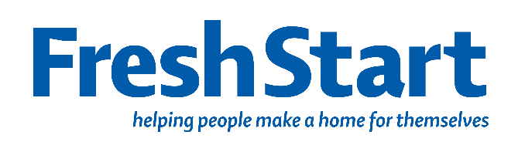
Fresh Start is committed to processing information in accordance with General Data Protection Regulation (GDPR). The data collected on this form will be held securely and will only be used for administrative purposes. By submitting this information, you confirm that you have secured the clients approval for Fresh Start to hold, store and use the information on our current databases in line with these processes.

Referring Agent’s Details |  | Date of referral
Name |  | Telephone
Organisation |  | Email Address
Department |  | Email Address
Please indicate the service user understands GDPR and is happy to submit this form YES ☐ NO ☐

Service user details
Name |  | Ethnicity
Date of birth |  | Gender
Address |  | Postcode
Telephone number |  | Email
Tenancy Start Date |  | First language
Household Status  (tick one box) | Single ☐  Single Parent ☐  Couple ☐  Couple with children ☐  Other two or more adults not a couple ☐  Other with children ☐ | Housing Status  Employment status | Currently homeless ☐  Has been homeless ☐  At risk of homelessness ☐  Employed FT ☐  Employed PT ☐  Unemployed ☐
Tenancy Type  (tick one box) | Council – core ☐  Council – unfurnished ☐  Housing Association ☐  Hostel ☐  B&B ☐  Temporary Accommodation ☐  Private Let ☐  Mortgaged ☐  Rough sleeping ☐  Sofa surfing ☐ | Other support needs or status tick all that apply | Mental health issues ☐  Physical health issues ☐  Learning disability ☐  Physical disability ☐  Drug/alcohol dependency ☐  Basic housing management ☐  Financial difficulties (e.g. debt/unemployment ☐  Care Leaver ☐  Served in armed forces ☐  Refugee ☐  Asylum seeker ☐  No other support needs ☐
Number of children in household, ages and gender |  | Any other info
We offer the following services. Please indicate any service you are referring to with an X, and we will contact you with further information.

Starter Packs  Provide essential household goods see below for full list of items.  Select what is required below. |  | Cooking Services  Classes, bespoke sessions and cook at home initiatives focusing on developing skills to cook healthy, nutritious, affordable meals. |  | Gardening  Join our gardening sessions in North Edinburgh and learn how to grow fresh produce, connect with people and enjoy the outdoors
White Goods – order priority items 1,2,3  Cooker ☐  Washing Machine ☐  Fridge freezer ☐  Must apply to Scottish welfare fund first if eligible for public funds/in receipt of benefits |  | Fresh Rooms service  Volunteer teams will help to paint up to 2 rooms in a tenancy for people who have moved in following a period of homelessness.  The referrer must be contactable as we will need additional paperwork to assess eligibility |  | Fresh Start Pantry  Access to affordable food for residents of Pilton, Muirhouse, Granton & Drylaw only.
Essential packs
Crockery/Cutlery |  | Sanitary pack |  | Food pack |  | Children’s bedding
Pots/pans, utensils |  | Towels |  | Single bedding |  | Lamp
Toiletries |  | Cleaning pack |  | Double bedding |  | Kettle
Occasionally, we can provide additional items, depending on what donations we have received, the items below are not guaranteed and will only be given as and when we have them in stock.
Toaster |  | Hair dryer |  | Ironing board
Toastie maker/grill |  | Media/CD Player |  | Light shades
Coffee machine |  | DVD Player |  | Cushions
Food blender |  | Clock radio |  | Clothes horse
Iron |  | Artwork/pictures |  | Mirror
Curtains small |  | Curtains medium |  | Curtains large
Popular items are vacuum cleaners, TVs and Microwaves, you may not receive all 3 if any, please indicate in order priority 1 – highest, 3 lowest
Vacuum cleaner ☐ Microwave/air fryer/slow cooker ☐ TV ☐

We operate based on donations, please be aware that you may not receive everything you have requested. We must prioritise our packs for those accessing the service for the first time, unfortunately, we cannot accept repeat referrals if we have been unable to provide all items requested in the first instance.
You will be contacted when the starter packs are ready. If you do not collect or contact Fresh Start within 5 days of being informed that the packs are ready for collection, your referral will be cancelled, and you will need to reapply for the packs.
Email this form back to: admin@freshstartweb.org.uk

